1. Explain the heap property of a tree

a parent node always has a greater value than its children nodes

2. List and describe the 3 methods most often associated with a stack.

push – add to the stack

pop – remove and returns from the stack

peak – look at the top without removing

3. Identify 3 errors in the following code snippet:

num = input()

def factorial[n]:

if n == 0:

return 1;

else:

return n * factorial(n-1)

num(factorial)

the brackets around n should be ()

semicolon is not used in python

the final return statement needs to be flipped

4. Suppose there are 2 circles on a cartesian plane at (1,1) and (4,1), with a radius of m and n respectively. Write psuedocode that determines if the two circles overlap.

if m + n >= 3:

return(“they overlap”)

else:

return(“they don’t overlap”)

5. Use pseudocode to design a class that represents a car.

Class Car:

def __init__(self):

self. make

self.model

self.year

self.mileage

self.seatage

def drive(destination, top speed, mpg):

# how far is the destination

# calculate the time it would take to reach the destination and how much gas is used

6. Explain the meaning and use of the global keyword in python

allows you to access the variable from anywhere else in the program7. Draw a binary search tree containing the items added in order of [14, 5, 21, 3, 7, 8, 9, 1, 12]:

smallest are always to the left in order following the tree down

8. Give the Big-O performance of the following code fragment:

Log(n)

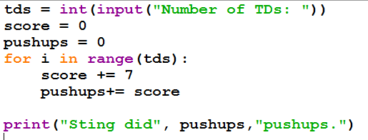

9.Give the Big-O runtime of the following code snippet:

log(n)

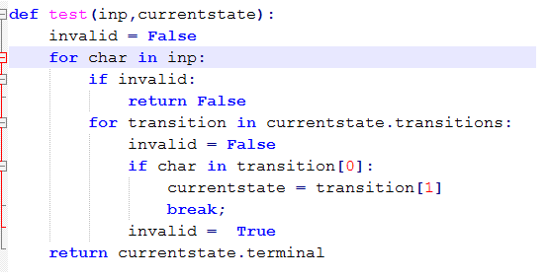

10. Write a python program that uses **a dictionary** to store the following states and capitals.

Des Moines, Iowa  
Jefferson City, Missouri  
Albany, New York  
Sacramento, California  
Austin, Texas  
Lincoln, Nebraska

Finally, print the capital of california from your dictionary.  
stateCapitals = {}

state = ""

capital = "”

def addStates(stateinput , capitalinput):

state = stateinput

capital = capitalinput

stateCapitals.append(state,capital)

addStates(Des Moines, Iowa)

addStates(Jefferson City, Missouri)

addStates(Albany, New York)

addStates(Sacramento, California)

addStates(Austin, Texas)

addStates(Lincoln, Nebraska)

print(stateCapitals)

print(stateCapitals.get(California))

11.Define the following terms in the context of computer science:

a. Complexity – a measure of the general runtime using Big-O

b. Heuristic – a shortcut to an otherwise challenging problem

c. Linear

d. Tree – a data structure that helps iterate through list faster

e. Stack – first in last out data structure that allows you to store multiple variables

f. Node – a value on a tree(all trees have nodes)

g. Graph

h. Queue – first in first out data structure that allows you to store multiple variables

i. Quadratic

j. Exception – prevents an error from crashing the program

k. Dictionary – a data structure that allows you to store multiple variables that are “associated” with each other like: {state: state capital}